Lesson 02 Demo 04

Quickstart ARM Templates

Objective: To configure Azure resources with ARM templates in powershell
Tools Required: None

Prerequisites: None

Steps to be followed:
- Explore the quickstart templates gallery
- Explore a template
- Run templates with PowerShell

Step 1.1: Explore the quickstart templates gallery

- Visit https://azure.microsoft.com/en-us/resources/templates/ in your browser to view available Azure templates

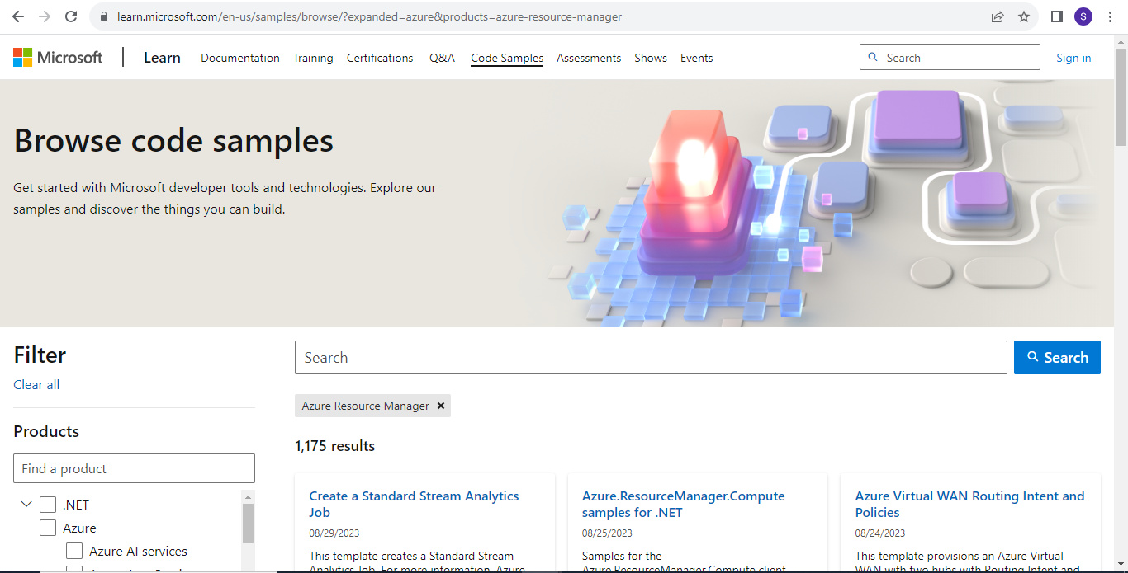

Step 2: Explore a template

  - Search for Deploy a simple Windows VM template

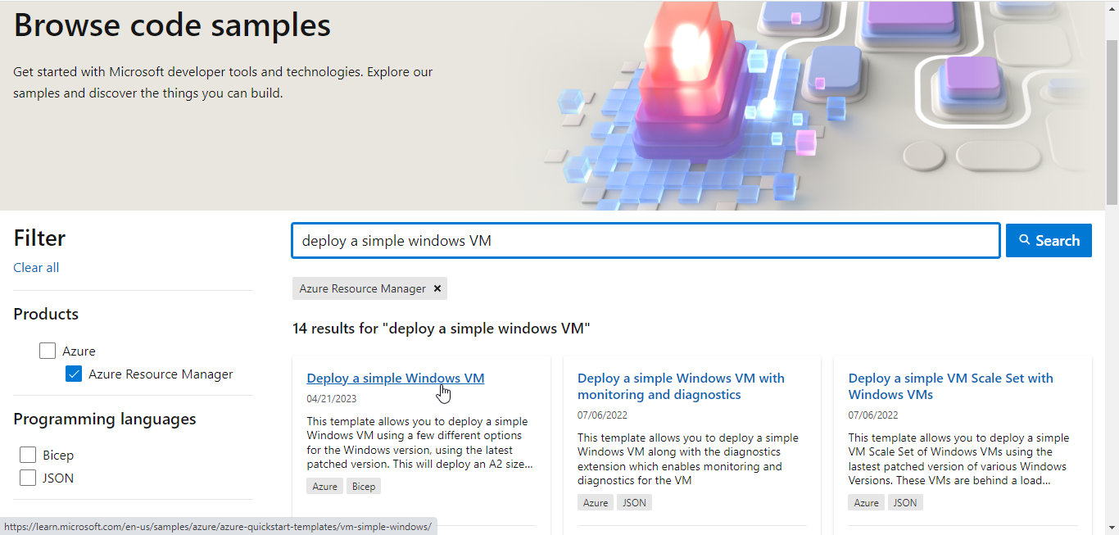

  - Click Visualize to navigate to the Azure Resource Manager Visualizer (ARMVIZ)

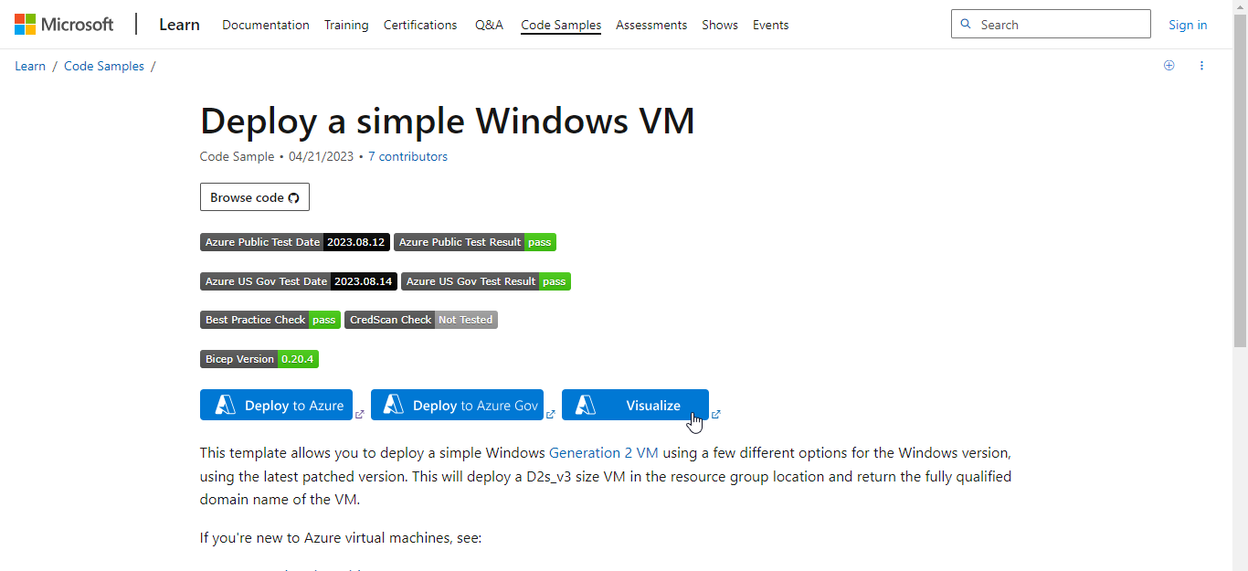

  - In the ARMVIZ portal, you can visualize the deployment composition, which includes a VM, a storage account, and network resources.

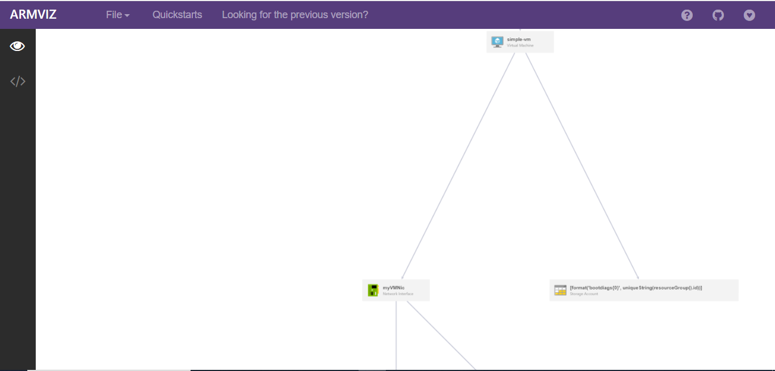

  - Click on Quickstarts to see the template's source code on GitHub

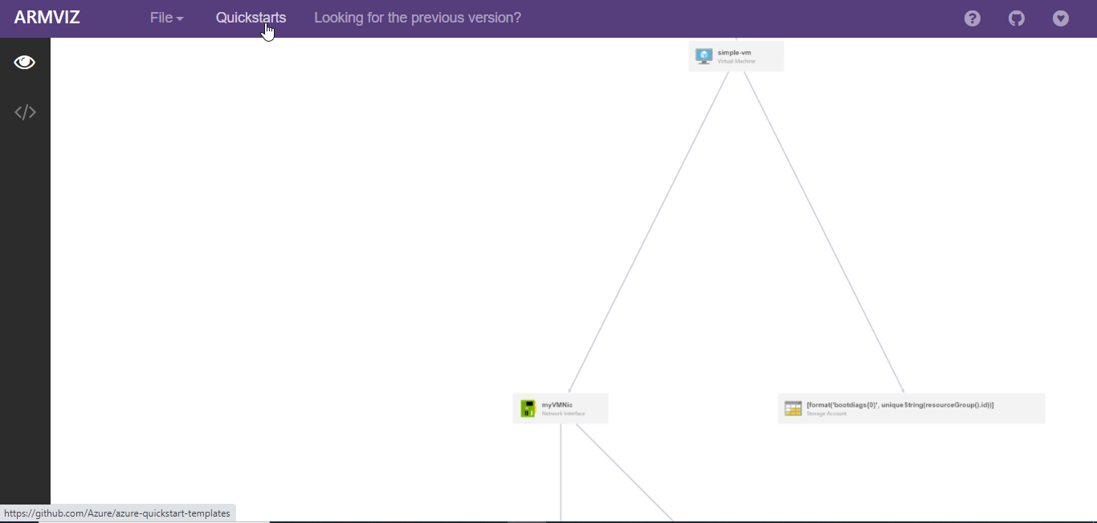

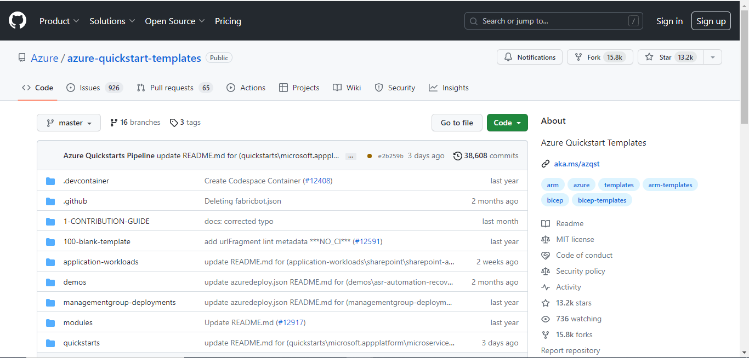

  - Click on </> to view the source code

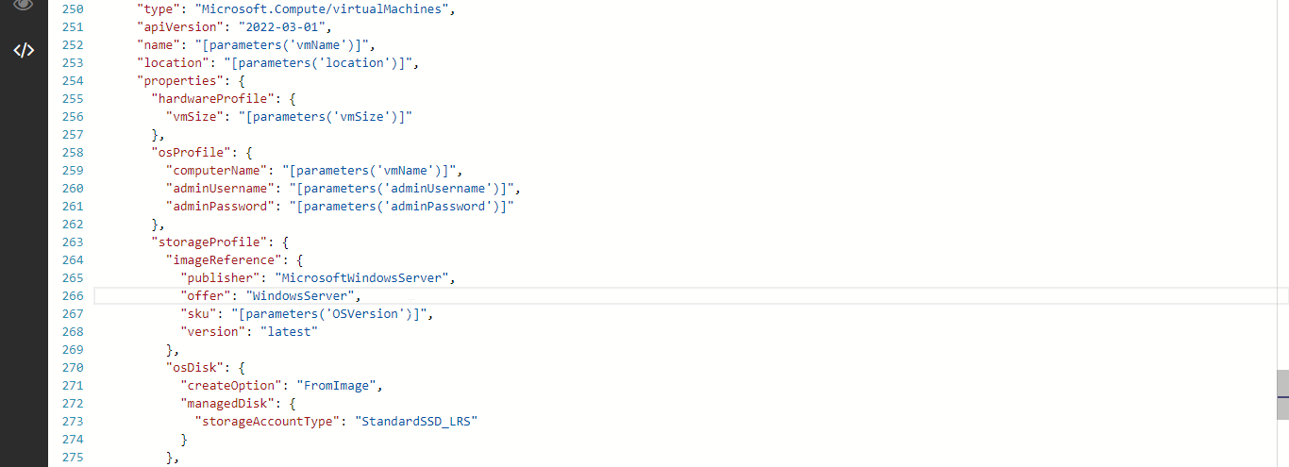

  - Review the source code that defines the VM resource
- The resource type is Microsoft.Compute/virtualMachines.
- Its location, or Azure region, comes from the template parameter named location.
- The VM's size comes from the template parameter named vmSize.
- The computerName is read from a template variable, and the adminUsername and adminPassword for the VM are read from template parameters.

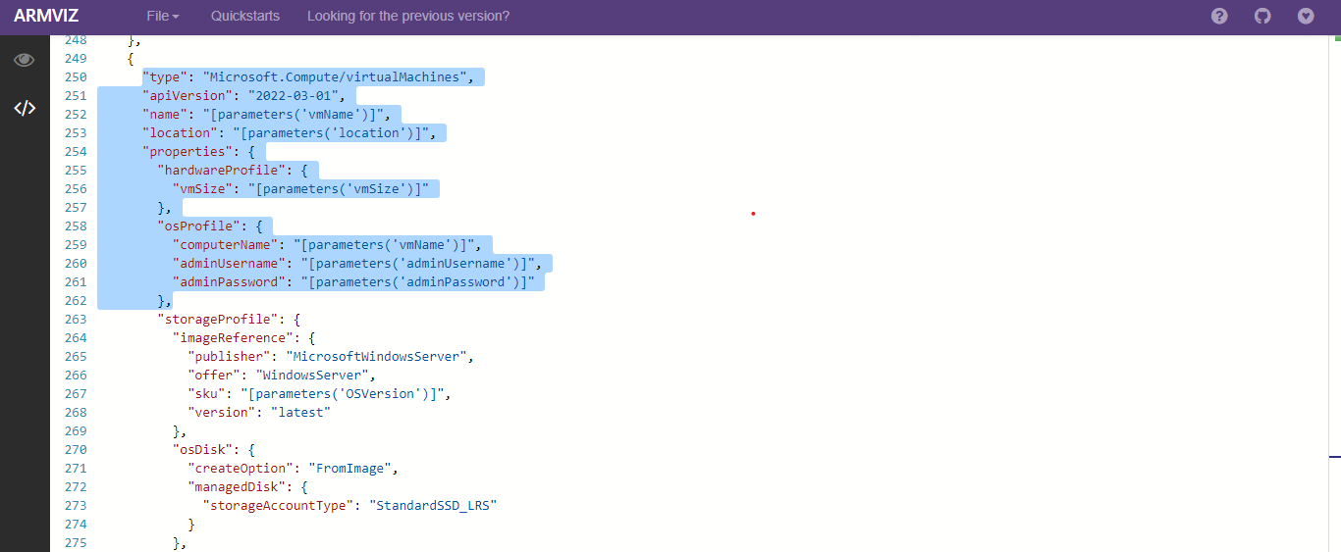

Step 3: Run template with PowerShell
  - Run the command Get-AzContext | Format-List to view details of the active Azure session, including the subscription

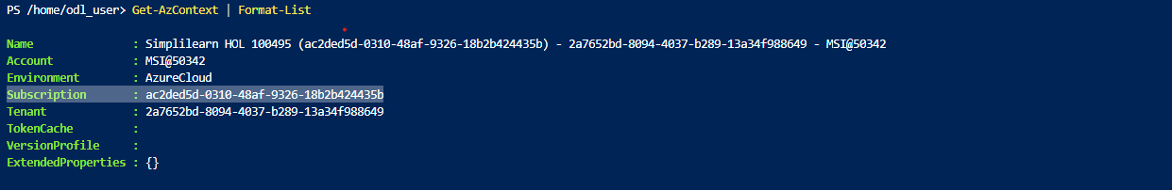

  - Use the command Set-AzContext -SubscriptionId <subscription id> to select the specified subscription

  - Create a resource group to deploy the template resources using the following command:
New-AzResourceGroup -Name < resourcegroup name > -location < region >

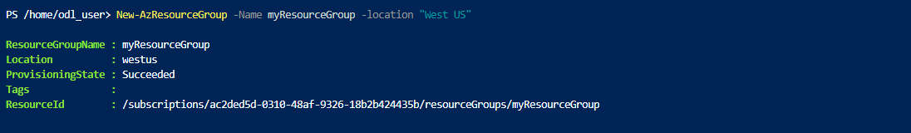

  - Download the JSON file from GitHub repository: https://github.com/Simplilearn-Edu/AZ104Template and upload it in the PowerShell

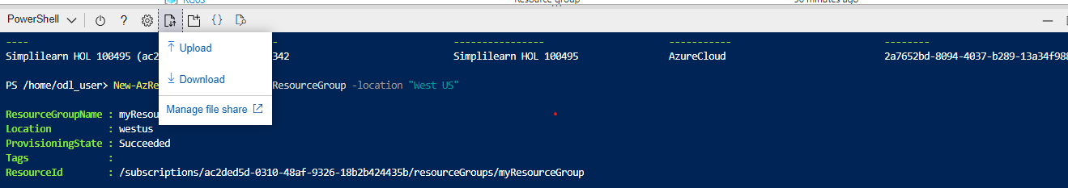

  - Use the command New-AzResourceGroupDeployment –ResourceGroupName <resource group name> -TemplateFile <file name> to deploy the ARM template to the resource group. Provide random adminUsername and adminPassword when prompted.

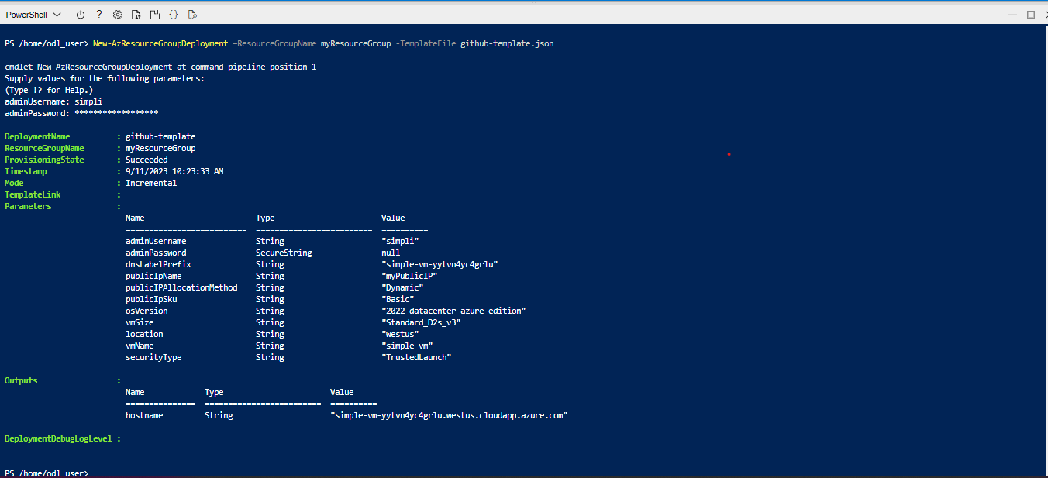

The output appears as shown below:

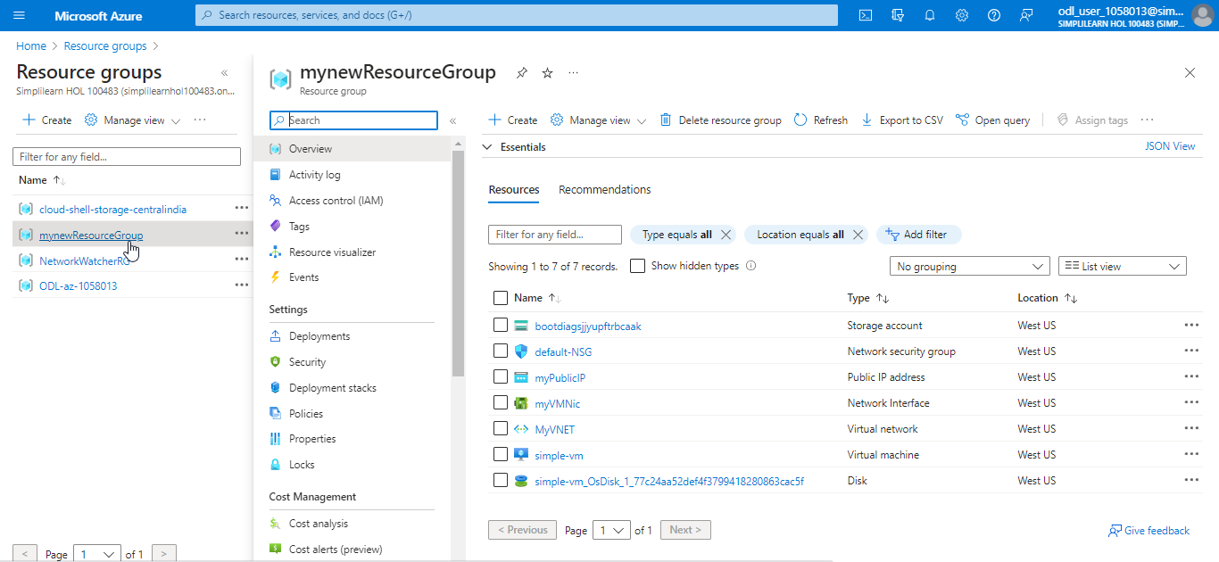

You have now successfully provisioned the Azure resources with Azure Resource Manager (ARM) templates.

